Sequencing noise? Mapping errors? Contamination? Or evidence for mobile mRNA?
We find that a substantial number of transcripts that have been reported to be mobile lack statistical support from available RNA-Seq data. Known issues, such as technological noise or biological variation, have been incorrectly interpreted as evidence for mobility.
This is a summary of:
Name, A. A. et al. Title. Nature https://doi.org/10.1038/xxxx (202x)
[We will complete this]
Published online: xx xx xxxx
Publisher’s note
Springer Nature remains neutral with regard to jurisdictional claims in published maps and institutional affiliations.
The question
Transport of messenger RNA (mobile mRNA) between cells and tissues has been shown to
play a role in several physiological and developmental processes in plants. The ability of mRNAs to travel over long-distances coupled with reports of mRNAs acting non-cell
autonomously has given rise to the suggestion that mobile mRNAs may act as systemic regulators or signals¹. Thousands of mobile mRNAs have been identified to date^{2,3}, potentially being key components in a complex intercellular communication system^{1,4}. The selection for transport has been reported to be specific, possibly governed by sequence motifs or zip-codes, and conditional on different stresses, developmental stages, and species². Our goal was to elucidate the molecular features that trigger mRNA translocation. This would enhance our fundamental understanding of mRNA transport and open up the exciting opportunity to develop a predictive framework for engineering plant communication processes.

SECTION 2: The discovery
For feature identification, we first sought to curate a high-quality dataset. Thinking about how ‘high-quality’ should be defined in this case, prompted us to carefully revisit how mobile mRNAs had been determined. Which mobile mRNAs are most reliable based on the available data? To answer this question, we need to consider that transcripts have different numbers of SNPs, different coverages, and varying levels of consistency between replicates. We also need to consider other explanations for the observed data. Is it possible that the criteria for classifying a transcript as mobile could met by other means? We devised a series of tests to distinguish signals from noise, based on inferences from homograft data. To evaluate the evidence in support of transcript mobility, we built a statistical model that accounts for error rates, read-depths, mapping quality, etc.
With the goal of finding mobile mRNAs with the most experimental support, we carried out a meta-analysis across existing mobile mRNA datasets. To our surprise, we found that technological noise, biological variation, contamination and incomplete genome assemblies can give rise to features in the data that match criteria that have been used to define mRNAs as mobile (Fig 1). We performed control experiments on simulated data and homograft data. Puzzlingly, we failed to find statistically significant differences between homograft and heterograft data, or between SNP positions and other positions in the sequence. Taking these considerations into account, we find that most transcripts that are currently annotated as graft-mobile are left without statistical support from available datasets.

SECTION 3: The implications
The finding that many mobile mRNAs are not supported by the data, raises questions regarding the extent of mRNA transport and mRNA communication. Our analysis suggests that we must entertain the possibility that previous studies may have over-estimated the number of mobile mRNAs in plants. Sequencing associated noise (reverse transcriptase errors, base-calling errors) and biological variation (differences to the reference genome assembly) may have led to transcripts being incorrectly classified as mobile. These considerations are consistent with previous observations, such as discrepancies between experiments, differences in mobility between close homologues, genome-scale transport, variability between replicates, and the documented read-depth dependence. Interestingly, in mammalian systems, mRNA transport was also found to be pervasive across the genome, in a non-selective and expression dependent manner⁵. Might our findings be broader? Might other SNP-based methods suffer from similar issues?
The experimental evidence for mobile mRNA is compelling. Whilst we demonstrate that the evidence for currently annotated mobile mRNAs is consistent with other explanations (sequencing noise, genome mapping errors, biological variation, contamination), this does not imply that they are not mobile. Without experimental confirmation we cannot say that those mobile mRNAs that lack statistical support are false positives.
Our findings challenge current views on the extent of mRNA communication and highlight that there is still much we don’t understand. We hope that our analysis and recommendations will contribute to unravelling the mechanisms and function of the fascinating phenomenon of long-distance mRNA transport in plants.
Richard J. Morris
John Innes Centre, Norwich, UK.

Expert opinion
This will be added by the briefing editor and included in the edited version of the Briefing you see.
Name of source, role
[max 80 words, including sign-off]


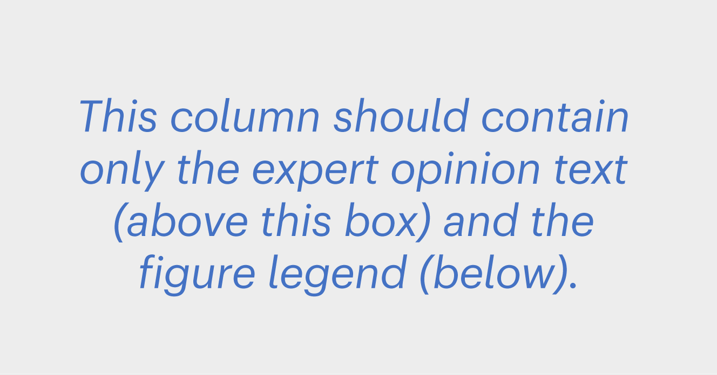

Figure
Please replace ‘xx’ in the following statements:

The figure for this Briefing is composed of 5 panels.
- Panels a,b,c,d,e = Fig 2 from the original paper

Fig.1 | Alternate explanations for mobility. a, A high percentage of mobile mRNAs are based on data that is consistent with sequencing errors. b,c, The data at SNP positions is no different from other positions and consistent with noise. d,e, Some datasets may be contaminated. © 202x, XXX
Behind the paper
Why were all our attempts failing to identify features or patterns in the data? Nothing worked. Frustrating. Were we doing something wrong? Were there simply no patterns? Did we not have enough data? Were the data too noisy?
We needed to dig deeper. The fantastic interactions with our collaborators, all the open discussion and enthusiasm for sorting this out were instrumental. The whole team worked tirelessly and synergistically. Turning point number one was the idea to evaluate different approaches using simulated data. This revealed the importance of error rates and read depths. Turning point number two was to revisit homograft datasets. This revealed that the statistical properties of homograft data are essentially the same as heterograft data. Something was amiss. Further investigation revealed genome mapping issues, pseudo-heterozygosity and potential contamination. The statistical support for mobile mRNAs was swiftly dwindling. R.J.M.
References
1. Lucus, W. J., Yoo, B. C. & Kragler, F. RNA as a long-distance information macromolecule in plants. Nature Reviews Molecular Cell Biology. 2, 849–857 (2001).
A Review article that describes the concept of RNA communication in plants.
2. Thieme, C.J., et al. Endogenous Arabidopsis messenger RNAs transported to distant tissues. Nature Plants. 1, 15025 (2015).
This paper reports over 2000 mobile mRNAs.
3. Kim, G., LeBlanc, M.L., Wafula, E.K., dePamphilis, C.W. & Westwood, J.H. Genomic-scale exchange of mRNA between a parasitic plant and its hosts. Science. 345, 808-811 (2014).
This paper reports on the large-scale exchange of mRNA between species.
4. Heeney, M. and Frank, M. H. The mRNA mobileome: challenges and opportunities for deciphering signals from the noise. The Plant Cell. 35, 1817-1833 (2023).
A Review article that presents a discussion of signals and noise in mRNA communication.
5. Dasgupta, S., et al. Global analysis of contact-dependent human-to-mouse intercellular mRNA and lncRNA transfer in cell culture. eLife. 12, e83584 (2023).
This paper reports that mRNA transfer is non-selective and strongly correlates with expression levels.


From the editor
This will be added by the briefing editor and included in the edited version of the Briefing you see. Name of editor
[max 75 words, including sign-off]

